EPR method: methemoglobinemia in patients with connective tissue dysplasia

M.I.Ibragimova¹, A.I. Chushnikov¹, I.V.Yatsyk¹, D.Kh.Khaibullina², G.G.Gumarov¹

¹Zavoisky Physical-Technical Institute, FRC Kazan Scientific Center of RAS, Kazan, Russia
²Kazan State Medical Academy - Branch Campus of the FSBEIFPE RMACPE MOH, Russia

Hemoglobin (Hb) is a complex protein that is the main component of red blood cells. Hb consists of the protein globin and heme, a porphyrin core containing ferrous iron. Under the influence of a number of endogenous and exogenous factors (such as nitrogen oxides, chlorates, some toxic and pain-relieving drugs), oxidation of heme iron from Fe²⁺ (d⁶) to Fe³⁺ (d⁵, high-spin ferric state) can occur, that is, the formation of methemoglobin (MetHb). Normally, the concentration of MetHb should not exceed 2% of the total hemoglobin concentration. Since the iron in MetHb is in an oxidized state (Fe³⁺ instead of Fe²⁺), this form of hemoglobin is not able to transport oxygen. This fact means that an increase in MetHb concentration can lead to methemoglobinemia, a condition in which oxygen transport to tissues is impaired.
One of the fairly common pathologies is connective tissue dysplasia (CTD) - a multi-organ and multi-system pathology with progressive clinical course. There are several aspects that may link methemoglobin and CTD, although these connections are currently hypothetical. In essence, this is an increased risk of developing methemoglobinemia due to oxidative stress, which disrupts the structure and function of connective tissue. Moreover, elevated methemoglobin levels can aggravate tissue hypoxia, which negatively affects the condition of connective tissue.
In this work, blood samples of patients with connective tissue dysplasia associated with back pain were studied using the X-band EPR in the temperature range of 5 - 80K. EPR spectra were recorded using the spectrometer "Bruker Plus" at a frequency of ~9.38 GHz with a modulation frequency of 100 kHz, modulation amplitude of 5 G and microwave power of 20 mW from blood samples of equal volume (0.15 ml).
Fig. 1a-b show the EPR spectra of blood recorded at 5 and 80K, respectively. As can be seen from Fig.1a, at a temperature of 5K the absorption line from Fe³⁺ - MetHb with g = 5.81 dominates. Along with the signal from ferric heme, two more (but not intensive) absorption lines with g-factors of 6.37 and 5.31 are visible in the three spectra, having non-equivalence of the EPR absorption along the x and y-directions in the heme's plane. This signal is attributed to the high spin ferric heme state of erythrocyte catalase [1]. As can be seen from Fig. 1, the amplitude of the signal (peak-to-peak) from Fe³⁺ - MetHb in spectra 1-3 at both 5K and 80K, although different, is more than two orders of magnitude smaller than the signal from ferric heme in spectrum 4.
Temperature dependences of the EPR spectra of blood for samples 2 and 4 are shown in Fig. 2. Firstly, it was found that with an increase in temperature from 5 to 80 K, the intensity of the signal from Fe³⁺ - MetHb decreases significantly. At the same time, even at 80 K, the signal from Fe³⁺ - MetHb dominates in the EPR spectrum of sample 4 (see Fig. 1b and 2b). Secondly, with an increase in temperature, the line width from Fe³⁺ - MetHb increases. It was found that both the absolute value of the line width and the nature of its change (Δ) in the temperature range of 5 – 80 K are different for samples 2 and 4. At 5 K, the line width is 105 and 130 G in spectra 2 and 4, respectively. The increase in line width in the range from 5 to 80K is Δ ~45 G for sample 2 and Δ ~ 65 G for sample 4. Note that the blood serum spectrum from sample 4 does not have any anomalies and is similar to all the samples tested.
Such a significant difference in the concentration of Fe³⁺ - MetHb in sample 4 relative to samples 1-3 is due, in our opinion, to the severity of CTD. Sample 4 is the blood of a patient with the third (maximum) degree of CTD (male, 17 years old). Against the background of all the main factors causing CTD, such a high degree of methemoglobinemia, apparently, significantly affects the condition of the connective tissue due to hypoxia.
It should be noted that even with a less pronounced degree of severity of CDT (spectra 1-3), the concentration of Fe³⁺ - MetHb is quite high and even with one degree of CDT it can differ by more than 2 times at a temperature of 5K.
We think that in the pathogenesis of connective tissue dysplasia, the role of MetHb can be significant, especially in severe CTD. Moreover, the mechanism leading to the formation of methemoglobin, especially in the context of oxidative stress, may be different at different degrees of CTD. Obtained data will certainly be of interest and require further research.

- Svistunenko D. A.: J. Biomed Res., 35, 294 (2021).
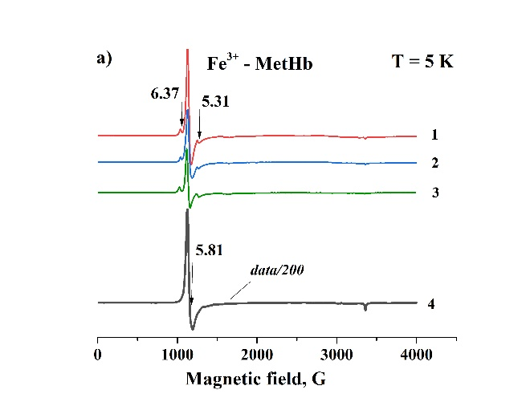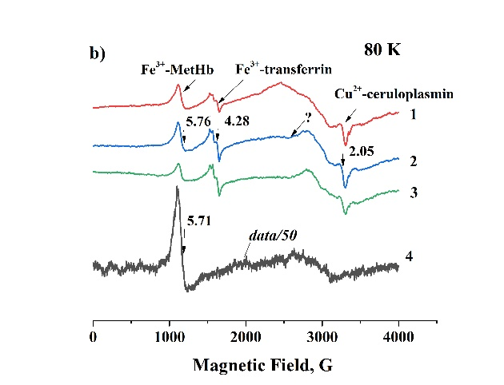
Fig.1. X-band EPR spectra blood recorded at 5K (a) and 80K (b)
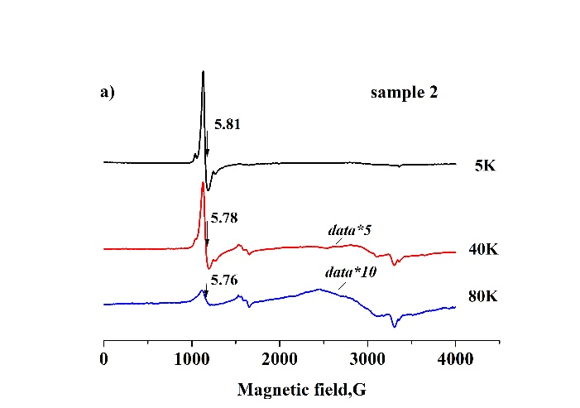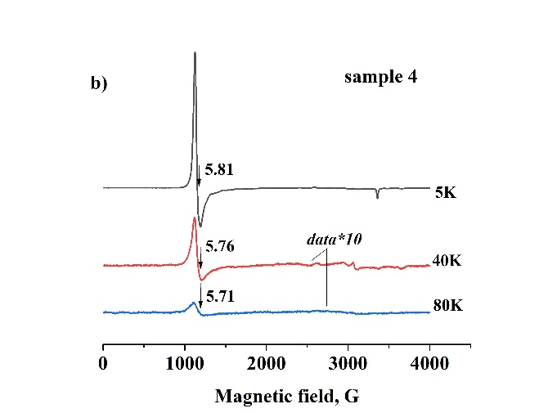
Fig.2. X-band EPR spectra of blood recorded in the temperature range from 5 to 80K

