SPATIAL ORGANIZATION of POLYMER-METAL COILS in LIQUID SOLUTIONS: “Spin Exchange Titration”
A.I. Kokorin
N.N. Semenov FRC for Chemical Physics of RAS, Moscow, Russia
Spin Exchange Titration (SET) characterizes the efficiency of spin exchange in liquid solutions between paramagnetic metal ions coordinated by complex-forming polymers With Nitroxide spin probes of constant concentration. [1, 2].
It is evident to all EPR spectroscopists that spin exchange reaction reflects not only kinetics of paramagnetic species (PS) collisions but also effects of the PS nature, spin-relaxation parameters, steric hindrances, Colomb charges, etc. The approach SET is an especially useful EPR technique characterizes ability of small molecules and ions in liquid solutions to penetrate inside the globe of metal-complexing polymers or ion exchangerts. That gives the important information about spatial organization of such polymer-metal complexs which is useful for catalytic systems.

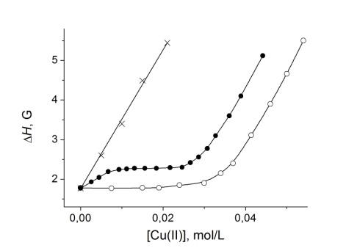

Fig. 1. Elfect of Cu(N0₃)₂ concentration on EPR line width ΔH in the absence (×) and presence of BPEI ([N] = 0.08 M) (●), and P4VP-E, β = 36%, ([N] = 0.36 M (○)) at 298 K.

Dependences presented in Fig. 1 can be easily explained. One can conclude analyzing these data that:
1) without complex-forming polymers (×), linear broadening of nitroxide spin probe lines ΔH is caused by usual spin exchange coupling between NSP and Cu(II) ions.
2) In the case of P4VP-M, β = 36% (○), the area of ΔH independence vs. [Cu(II)] in the range of 0 < [Cu] < ~0.02 mol/L exhibits that CuN₄ complexes formed with pyridine residues (Py) [1] are not available for collisions with small molecules (NSP). One can estimate a fraction of Py links the total amount of CuN₄ complexes in the polymer coil in H₂O+CH₃OH mixture at 298 K: 26 ± 2% N atoms form Cu(N)₄ complexes, additional ~13% N form Cu(N)₃ and Cu(N)₂ structures [3, 4], while ~60% links are free pyridine residues i.e. are not involved into metal complex formation.
3) In the case of BPEI (●), approximately ~40% ethyleneimine links –CH₂CH₂N- are involved in Cu(N)₄ complexes [5] and afterwards, up to ~90% N participate in “clusters” of Cu(N)₄ complexes self-organized in BPEI and LPEI coils [5, 6]. Indeed, at the first interval (0 < [Cu(II)] < ~0.008 M) a slope of ΔH dependence (Fig. 1) is approximately twice less than for spin exchange in the case without polymers (×). In this interval, only isolated Cu(N)₄ complexes do exist in PEI coils [6]. Afterwards, at ~0.008 M < [Cu(II)] < ~0.018 M, ΔH ≈ const, i.e., new complexes forming in BPEI (as “clusters”) are not available for collisions with NSP. At [Cu(II)] > ~0.02 M, newly added copper ions are actively involved into spin exchange.

Acknowledgement: We are thankful to Program of Fundamental Research of the Russian Federation (Reg. No: 125012200595-8).

1. Kokorin A.I.: Polymer Yearbook 13, 141-161 (1996)
2. Kokorin A.I., Pridantscv A.A.: Russ. J. Phys. Chem. 71, 1963-1968 (1997)
3. Kirsh Yu.E., Kovner V.Ya., Kokorin A.I., Zama-raev K.I., Cherny-ak V.Ya., Kabanov V.A. Europ. Polymer J. 10, 671-678 (1974).
4. Kokorin A.I., Zama-raev K.I., Kovner V.Y., Kirsh Yu.E., Kabanov V.A. Europ. Polymer J. 11, 719-722 (1975).
5. Kabanov N.M., Kokorin A.I., Rogacheva V.B., Zezin A.B. Polym. Sci. USSR. 21, 230-240 (1979).
6. Kokorin A.I., Shubin A.A. Russ. J. Strukt. Khim. 30, 106-112 (1989).

