Research a relaxation processes of E’ centers in pure quartz fibers by electron paramagnetic resonance method
L.V. Nikiforov¹, D.V. Dmitrieva¹, D.S. Dmitrieva¹, V.V. Davydov^{2, 3}
¹St. Petersburg State University of Telecommunications named after Prof. M. A. Bonch-Bruevich, Saint-Petersburg, Russia
² Peter the Great St.Petersburg Polytechnic University, Saint-Petersburg, Russia
³ Saint-Petersburg Electrotechnical University “LETI”, Saint-Petersburg, Russia

In the modern world there is a constant increase in radiation background, as well as factors and materials that create additional γ - radiation to the existing natural level [1]. Optical systems are the most sensitive to γ - radiation, especially under prolonged exposure. Under the action of γ - radiation in the optical material coloration centers are formed, which deteriorate its optical characteristics [2]. Optical fibers, especially on trunk lines and in communication and equipment control systems (e.g., at nuclear power plants and others) are subjected to various effects of γ - radiation. Various defects are formed in the fiber, which create great problems in the transmission of information or control and monitoring commands.
The most complex both in structure and relaxation processes are defects that belong to E' centers. These defects form dark-colored (opaque to radiation) points in the fiber structure with the size from 200 to 230 nm depending on the type of the optical fiber material structure [3]. At their large accumulation in the fiber core the laser radiation is completely attenuated and the transmitted information is lost. The developed method of optical fiber cleaning from coloration centers using ultraviolet laser radiation [4] has a number of limitations in its application. The most significant limitation is related to the distance (optical fiber length) of its application. The optical signal attenuation coefficient (scattering loss) of laser radiation at λ = 216 nm for different types of optical fibers is more than 8.2 dB/km. For this reason, the efficiency of its application at distances greater than 3000 m is zero. Other methods to clear the fiber from the coloration centers are currently not available. For this reason, numerous studies are aimed at developing technologies to reduce the influence of γ - radiation on the rate of formation of dye centers, especially E' centers. Different concepts to reduce this influence are proposed.
In our work we consider a concept related to the increase in the resistance of optical fiber to the formation of E' centers. Exposure of optical fibers to γ - radiation leads to two radiation effects: displacement and ionization. Displacement is associated with the shift of atoms from a stationary state in the crystal lattice to a more unstable state. This defect mainly applies to germanium oxide doped fibers. Numerous experiments have shown that the most radiation-resistant fibers are those with a core of pure quartz [2-4]. They are characterized by a defect associated with ionization, as a result of which electron-ion pairs are formed. The high-energy electron knocks out oxygen from the OH compound and takes its place in the crystal lattice. Our research will be aimed at determining the conditions in the technology of manufacturing optical fibers from pure quartz (first of all, the freezing temperature) and processing of quartz after manufacturing, which will make changes in the structure of the crystal lattice, changes the coordinate configuration Cc and make the fiber more resistant to the effects of γ - radiation (the process of formation of E' centers will begin at higher doses of absorption). Studies of various pure quartz samples irradiated with different doses of γ-radiation absorption were realized on Bruker EMX EPR spectrometer operating at 9.8 GHz. The studies were carried out at a modulating magnetic field frequency of 100 kHz, modulation amplitude of 0.01 mTL and microwave power of 800 nW. Fig. 1 shows for example the result of the variation of the energy of states from the configuration coordinate for two line shapes L1 and L2 obtained at low and high dose of ionization irradiation.
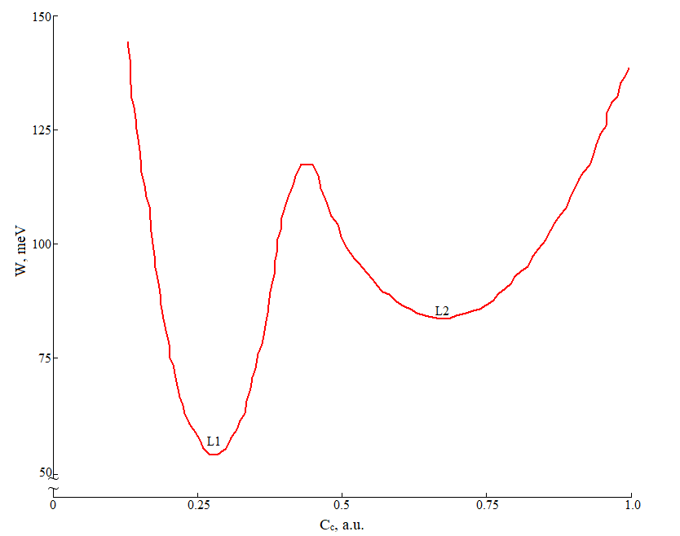
Fig.1 Total energy for the structural configurations of the E' centers associated with the experimental L1 and L2 line shapes.
The axial form of the L1 line is observed after irradiation with low doses and may be associated with those centers of formation in which electron substitution is energetically favorable. As the irradiation dose increases, other centers are formed in the state of metastable configuration associated with the orthorhombic form of the L2 line. The transformation from L2 to L1 is induced by heating and can be explained by considering that part of the energy of thermal fluctuations is used in the structural transformation in which the metastable centers change to more stable ones. Typologies of E' centers in SiO₂ have been established, which are distinguished by small variations in the shape of the EPR line, which can be related to different atomic compositions of the vicinity of the unpaired electron. Moreover, it is for the E' center that the evolution of the line shape after thermal treatment at a temperature of T∼500 K was found, which indicates the existence of unexplained degrees of structural freedom of the defect that further affect the attenuation of the optical signal in the fiber.
1. Rana S., Subbaraman H., Fleming A., Kandadai N.: Sensors. 21, 4111—4122 (2021)
2. Girard S., Alessi A., Richard N.: Reviews in Physics. 4, 100032 (2019).
3. Girard S., Kuhnhenn J., Gusarov A., Brichard B., Van Uffelen M., Ouerdane Y. IEEE Transactions on nuclear science. 60(3), 2015-2036 (2013).
4. Dmitrieva D.S., Pilipova V.M., Dudkin V.I., Davydov R.V., Davydov V.V. Lecture Notes in Computer Science (including subseries Lecture Notes in Artificial Intelligence and Lecture Notes in Bioinformatics).13158 LNCS, 230–239 (2022).

