SPIN DYNAMICS OF DISORDERED STRUCTURES AND ONE-DIMENSIONAL CHAINS
E.I. Kovycheva¹, K.B. Tsiberkin¹, V.K. Henner¹
¹ Perm State University, Perm, Russia

Different modifications of carbon, such as fullerene arrays, have electrical, optical and mechanical properties that are valuable for practical applications. Also, there are additional possibilities to modify their parameters and stabilize various configurations [1]. In particular, they are potentially applicable for creating electrodes with a high specific surface area in energy storage devices (capacitors, batteries). The properties of these materials can be controlled by introducing metal cores into the shells or by depositing magnetic ions on the carbon surface. In addition, the described materials can find applications in the development of new systems for storing, processing and transmitting information using spin magnetic moments [2].
The numerical method used in our previous works is modified to perform calculations in a rotating coordinate system and supplemented by the construction of Fourier spectra of the obtained magnetization signals. Calculations were performed for ordered (chain, square lattice) and disordered (magnetic particles randomly located on the surface of a nanosphere and nanotube) structures.
Spectra of an ordered rectangular structure of 9 spins in a rotating coordinate system (RCS) at different parameters of dipole interaction (pd):
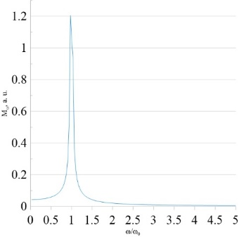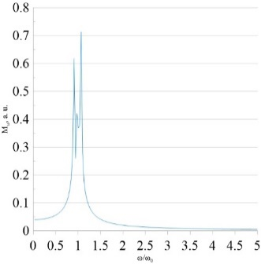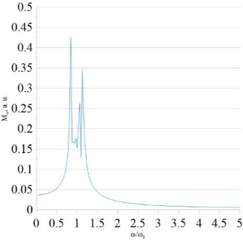
a b c
Fig. 1. Spectrum of an ordered rectangular lattice of 9 spins in the RCS, а – pd = 0.01, b – pd = 0.025, c – pd = 0.05

We can note that in an ordered planar structure in a rotating magnetic field, an increase in the dipole interaction parameter leads to the division of the main peak into several peaks (Fig. 1).
Now let us consider the spectra of disordered spherical and cylindrical structures of 9 spins in a rotating coordinate system (Fig.2):
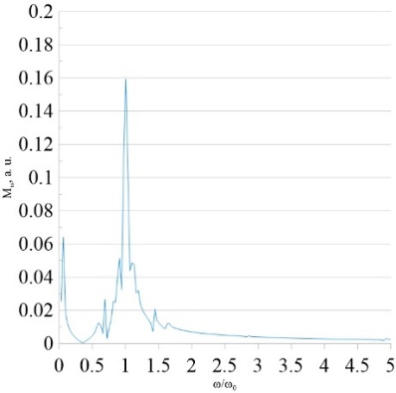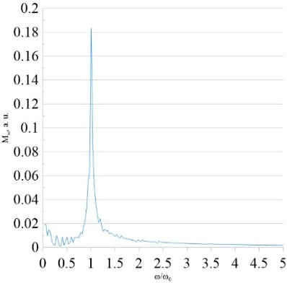
a b
Fig. 2. Spectrum of disordered random structure in the RCS for 9 spins, number of realizations 20, pd = 0.025. a – spherical structure; b – cylindrical structure.

At these graphs of the spectra of spherical and cylindrical structures (Fig. 2) additional peaks are observed close to zero. It is noticeable that these peaks appear only in the RCS spectra, and only for disordered structures (in the spectrum of a rectangular ordered structure we cannot see the same thing (Fig. 1)). Also there is no strong division of the main peak into several, as was the case with the ordered rectangular structure. (Fig. 1).
In the second part of the work, one-dimensional chains of spins were studied. These chains were oriented at different angles to the external field. The influence on signals and spectra was also considered. The influence of random deviations in the chain structure on signals and spectra is also considered. (Fig. 3).
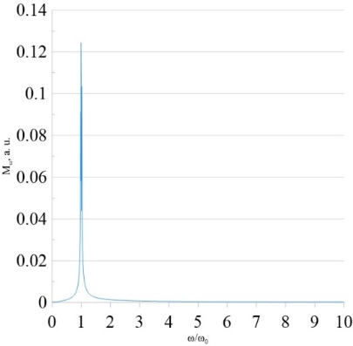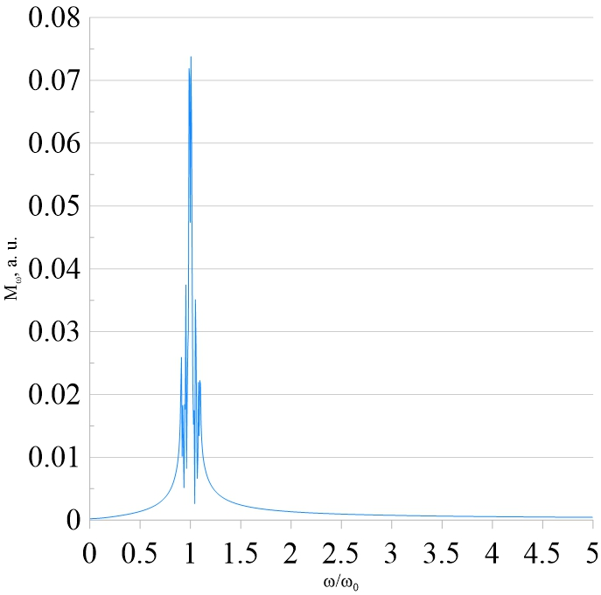
a b
Fig. 3. а - spectrum of a disordered stationary chain of 9 spins with a spread of 0,01, pd = 0,025, number of realizations 50; b - spectrum for a chain of 9 spins with a spread of 0.15. pd = 0.025, number of realizations 100

1. Sosunov A. V., Tsiberkin K. B., Henner V.K. The effect of functionalization of carbon nanoshells on their elec-trical properties. Bulletin of Perm University. Physics, 2019, no. 2, pp.63–68. doi:10.17072/1994-3598-2019-2-63-68
2. Tsiberkin, K.B. Wave Dynamics of Magnetization of a Ferromagnetic Impurity in a Paramagnetic Matrix. Phys. Metals Metallogr. 122, 358–361 (2021).

