COLLECTIVE MODES APPROACH
FOR SIMULATING THE SHAPE OF EPR LINES
S.O. Travin¹, K.M. Salikhov²
¹N.N. Semenov Federal Research Center for Chemical Physics Russian Academy of Sciences, Moscow
² Zavoisky Physical-Technical Institute, FRC Kazan Scientific Center of RAS, Kazan, Russia
The shape of the EPR spectrum in conditions when spin exchange is an essential feature of the spin system contains peculiar information about . The mathematical model of such systems used in our work was the paradigm of collective modes developed by Kev Salikhov in the last ten or more years [1]. Our task was to extract the quantitative parameters of this model and correlate them with the physical characteristics of the environment in which the measurements were taken. Thus, our idea, if successfully developed, can be used to determine the characteristics of molecular dynamics in a wide variety of objects, such as membranes, glasses, colloidal systems, semiconductors, superconductors etc.
At present, the most widespread approach for simulating and analyzing the EPR spectra in the presence of the coherence and dephasing transfer is usage of pseudo-Voigt individual line shape for each individual resonance. Despite the fact that this method most often gives an excellent fit of experimental spectra, it suffers from a very serious inherent drawback: an excessive number of tuning parameters. And the inevitable consequence of this vice is that it is extremely difficult to give any physical meaning to these parameters, especially to compare them with theoretical forecasts.
The alternative approach is to numerically simulate spectra and to fit the spectrum observed in a real experiment by varying the coherence transfer rates using eigenvectors of spin-Hamiltonian.
New approach [2] is based on finding the collective coherence modes. It makes possible to describe on a common platform the transformations of spectra at any coherences transfer rates: from the very slow coherence transfer rate which leads to line broadening, then to the rate which gives the coalescence (or association) of the spectral lines and further to the very fast rate which leads to exchange narrowed spectra.
In this case the number of adjustable parameters in the model is minimal. For example the spin exchange for triplet spectra of TEMPOL in the wide range of concentrations can be fitted with collective mode with only three parameters (Fig.1), instead of 12 parameters for pseudo-Voigt approach.
Moreover, all these three parameters (namely hyperfine splitting a, own line width
$Γ=1/{T_{2}}$ and coherence transfer rate $V=k_{ex}C$) has very clear sense and can be quantitively estimated theoretically.
On the Fig.2 there is plot of concentration dependence of $V$, from which one can readily estimate the mobility of the radical in the medium ( it’s diffusion coefficient) and the collision radius for the exchange interaction.

1. К. M. Salikhov Fundamentals of Spin Exchange. Story of a Paradigm Shift. © Springer Nature Switzerland AG 2019 https://doi.org/10.1007/978-3-030-26822-0
2. К. M. Salikhov Consistent Paradigm of the Spectra Decomposition into Independent Resonance Lines Appl. Magn. Reson. (2016) 47:1207-1227 DOI IO.I0O7/s0O723-OI6-O823-3

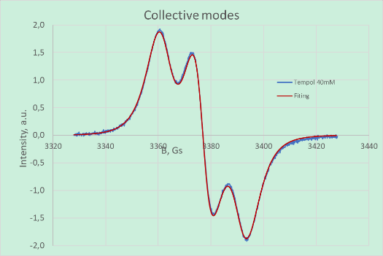 | 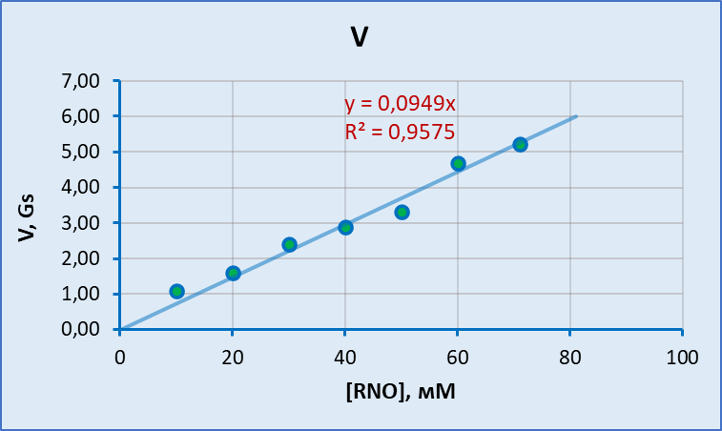
Fig. 1. Typical fitting of EPR line with collective mode eigen resonances, including absorption and dispersion. Note, that regression function includes only three adjustable parameters. | Fig. 2. Linear dependence of empirically determined coherence transfer rate on the concentration of radical. The slope of the straight line allows to determine the diffusion coefficient in the medium and the collision radius for the exchange interaction.

