MAGNETIC RESONANCE in NANOGRANULAR COMPOSITES: OBSERVATION of “DOUBLE-QUANTUM” EXCITATIONS in FERROMAGNETIC NANOPARTICLES

M.Yu. Dmitrieva^{1,2}, A.B. Drovosekov¹, A.V. Sitnikov^{3,4}, S.N. Nikolaev⁴,
V.V. Rylkov^{4,5,6}
¹ Kapitza Institute for Physical Problems, RAS, 119334, Moscow, Russia
² National Research University Higher School of Economics, 101000, Moscow, Russia
³ Voronezh State Technical University, 394026, Voronezh, Russia
⁴ National Research Centre "Kurchatov Institute", 123182, Moscow, Russia
⁵ Institute of Theoretical and Applied Electrodynamics, RAS, 125412, Moscow, Russia
⁶ Fryazino branch of the Kotelnikov Institute of Radio Engineering and Electronics, RAS, 141190, Fryazino, Russia

Films of metal-insulator nanogranular composites M_{x}D_{100−x} with different compositions and percentage of metallic and dielectric phases (M = Ni, CoFeB;
D = Al₂O₃, ZrO₂; x ≈ 10−80 at.%) were studied by magnetic resonance technique. Each of the studied samples (thickness ~ 1 μm) was an ensemble of ferromagnetic (FM) metal nanogranules (size of 2–8 nm), randomly located inside of an amorphous oxide dielectric matrix. The experiments were carried out in a wide range
of frequencies (f = 7−37 GHz) and temperatures (T = 4.2−300 K) at different orientations of the magnetic field (up to 17 kOe) with respect to the film plane.
It was found that at concentrations of the metallic FM phase below
the percolation threshold, the experimental spectra, besides the usual signal
of the ferromagnetic resonance (FMR), contain an additional absorption peak characterized by a double effective g-factor g_{eff} ≈ 4. Furthermore, the observed peak demonstrates a number of other unusual properties:
- It is better manifested in the longitudinal geometry of the resonance excitation.
- The temperature dependence of the peak intensity has a non-monotonic character with a maximum in temperature. This maximum shifts to higher temperatures with an increase of the FM phase content (Fig.1).
The appearance of such a peak in the resonance spectra can be explained
within the framework of the “giant spin” model [1] by excitation of “forbidden” (“double-quantum”) transitions inside the FM nanogranules with a change in the spin projection Δm = ±2. Within this approach, it is possible to explain the better manifestation of the g_{eff} ≈ 4 peak in the longitudinal geometry of the resonance excitation, as well as the anomalous temperature dependence of its intensity [1−3].

1. Noginova N., Weaver T., Giannelis E.P. et al., Phys. Rev. B 77, 014403 (2008).
2. Fittipaldi M., Mercatelli R. et al., Phys. Chem. Chem. Phys. 18, 3591 (2016).
3. Drovosekov A.B., Dmitrieva M.Yu et al., JETP 166, 383 (2024).

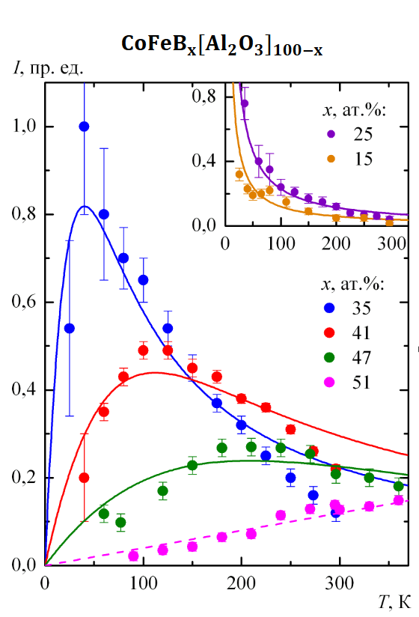

Fig. 1. Temperature dependences of the integral intensity of the additional absorption peak for different concentrations of the FM phase in films from the series of samples (CoFeB)_{x}(Al₂O₃)_{100-x} (different colors indicate different x values). Round signs correspond to experimental data, and lines – to the “giant spin” model.

