INVESTIGATION OF THE ORIGIN OF THE RADIATION-INDUCED PARAMAGNETIC CENTERS IN MELANIN BY EPR SPECTROSCOPY
Ivanova I.S.¹, Bajtimirov D.R. ¹, Konev S.V. ¹, Ivanov D.V. ^{1,2}, Podshivalov A.P. ¹
¹Ural Federal University, Yekaterinburg, Russia
² M.N. Mikheev Institute of Metal Physics, Ural Branch of the Russian Academy of Sciences, Ekaterinburg, Russia

The work is devoted to the study of radiation-induced centers (RIC) by the EPR method – free radicals arising in human hair samples under the influence of ionizing radiation.
It was previously shown that human hair can be used as an object for dosimetric measurements, since it is sensitive to ionizing radiation and is characterized by high RIS stability.
At the same time, human hair normally has a paramagnetic response with a complex EPR signal containing two main components – a wide one associated with the protein (keratin) structure of the hair and a narrow one corresponding to the pigment melanin, which gives color and intensity of hair coloring depending on the combination of its two types – eu- and pheomelanin. As a result, it turns out that the narrow component, in the case of using hair as an object of dosimetry, is a background signal.. The melanin content in hair of different colors varies significantly, because of that dosimetry on them will always have a systematic error. Thus, it is advisable to correct this error considering the color of a specific hair sample. In the course of the presented work, EPR signals were measured for more than 30 hair samples of different pigmentation, divided into five color groups - black, red, gray, light brown, dark brown - before and after irradiation with a dose of 10 kGy, created by a linear electron accelerator of the UELR-10-10S2 model. All samples have a characteristic EPR signal shape (Fig. 1), apparently associated with the molecular structure of the corresponding type of melanin.
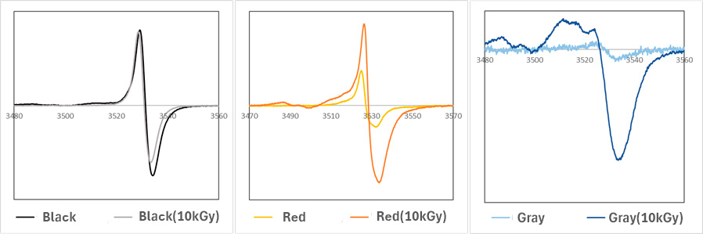
Fig. 1. Examples of EPR signals of hair of variable color before and after irradiation.
The study showed that the shape and characteristics of the RIS depend on the type and intensity of melanin pigmentation, according to the division of samples into corresponding groups, while the sensitivity of samples to IR increases with a decrease in the degree and type of sample pigmentation (Fig. 2).
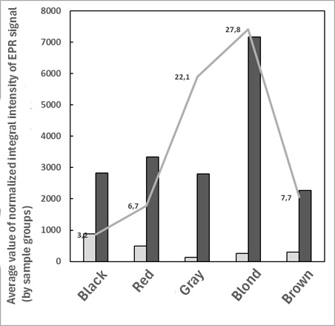
Fig. 2. Average values ​​of mass-normalized intensity of melanin EPR signals before (I_{background}, gray column) and after irradiation with a dose of 10 kGy (I_{irradiation}, black column), characterizing the corresponding groups of samples. The gray line shows the dependence of the I_{irradiation} / I_{background} ratio.
This behavior may indicate the radioprotective properties of eumelanin, which is predominant in black hair samples, which binds free radicals formed during irradiation. In samples of light and gray hair, a significant increase in the intensity of the EPR signal after irradiation may be associated not only with radiation-induced centers localized in pheomelanin granules, but also with radicals that arise during the destruction of the protein structure of the hair.

